SEC SEM 1 MIDSEM VIVA
PANSHUL VIKRAM AGGARWAL
BSC. CS. (H) Year 1
25570072

Q1. Create an HTML document with following formatting – Bold, Italics, Underline, Colors, Headings, Title, Font and Font Width, Background, Paragraph, Line Brakes, Horizontal Line, Blinking text as well as marquee text

<html>
<head>
<title>HTML Formatting</title>
<style>
body {
background-color: azure;
font-family: Arial, sans-serif;
}
div {
background-color: black;
}
.custom-font {
font-family: 'Courier New', Courier, monospace;
}
.wide-font {
font-stretch: expanded;
}
.blink {
color: beige;
font-size: 15px;
font-weight: bolder;
animation: blinker 1.25s linear infinite;
}
@keyframes blinker {
50% {
opacity: 0;
}
}
</style>
</head>
<body>
<h1>HTML Formatting Showcase</h1>
<h2 style="color:red;">Heading Level 2</h2>
<h3 style="color:Green;">Heading Level 3</h3>

<p class="custom-font wide-font">This is a paragraph using a <span style="color: red;">custom font</span> and <span style="font-weight: bold;">width expansion</span>.</p>

<p>
<b>Bold text example</b> <br>
<i>Italic text example</i> <br>
<u>underlined text example</u> <br>
<span style="color: red;">Red colored text</span> <br>
<span style="color: rgba(10, 155, 27, 0.745);"><b>Green colored text</b></span> <br>
</p>

<p>This is a normal paragraph with<br>line breaks using &lt;br&gt; tag.<br>
Each line appears separately.<br>
Horizontal rule below:</p>

<hr>

<div>
<span class='blink'>Blinking text using CSS!</span>
</div>
<br>
<marquee direction="left" scrollamount="6" style="color:rgb(205, 14, 167);">
This is marquee text scrolling left!
</marquee><br><br>
<marquee direction="right" scrollamount="6.1" style="color:rgb(213, 179, 8);">
This is marquee text scrolling right!
</marquee>

</body>
</html>

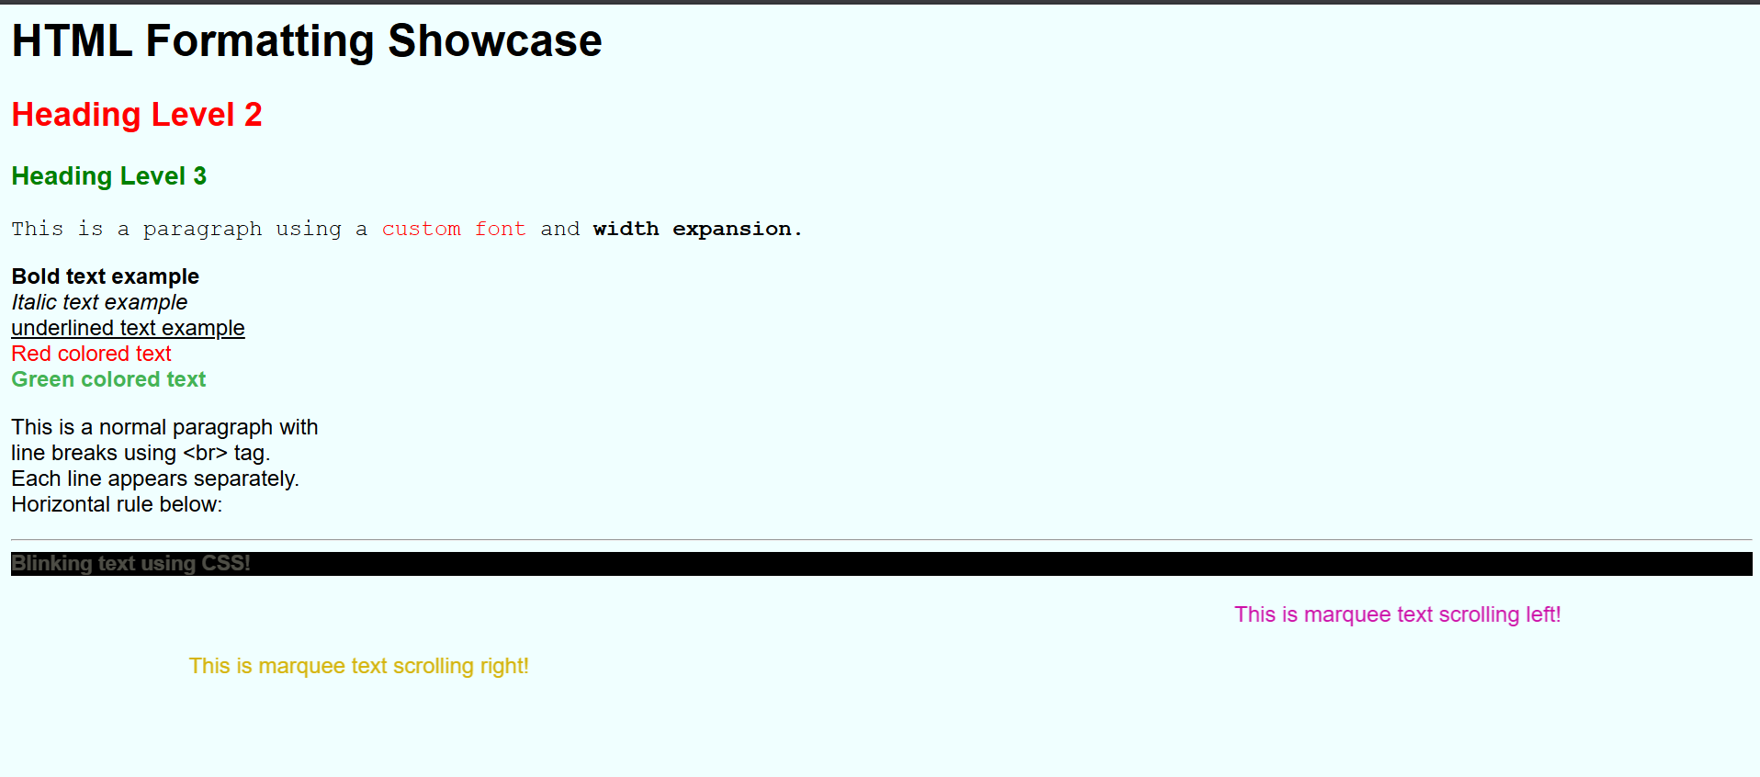

Q2. Create an HTML document with Ordered and Unordered lists,
Inserting Images, Internal and External linking

<html>
<head>
<title>HTML Lists, Images, and Links Example</title>
</head>
<body>
<h1>HTML Examples</h1>

<!-- Unordered List -->
<h2>Unordered List</h2>
<ul>
<li>Coffee</li>
<li>Tea</li>
<li>Milk</li>
</ul>

<!-- Ordered List -->
<h2>Ordered List</h2>
<ol>
<li>First Step</li>
<li>Second Step</li>
<li>Third Step</li>
</ol>

<!-- Inserting Images -->
<h2>Image Example</h2>
<img src="https://avatars.githubusercontent.com/u/231397395?v=4" alt="Demo Image" width="200">

<!-- Internal Link (to section in this page) -->
<h2 id="moreinfo">Internal and External Links</h2>
<p>Jump to <a href="#imageSection">the image section</a> (internal link).</p>

<!-- Internal Link (to another page in same folder) -->
<p>Go to <a href="1x.html">My first HTML</a></p>

<!-- External Link -->
<p>Visit <a href="https://github.com/PanshulVA?tab=repositories" target="_blank">My github</a> (external link).</p>

<!-- Link target inside same page -->
<h3 id="imageSection">Image Section</h3>
<p>This is a section that you can jump to from the internal link above.</p>
</body>
</html>

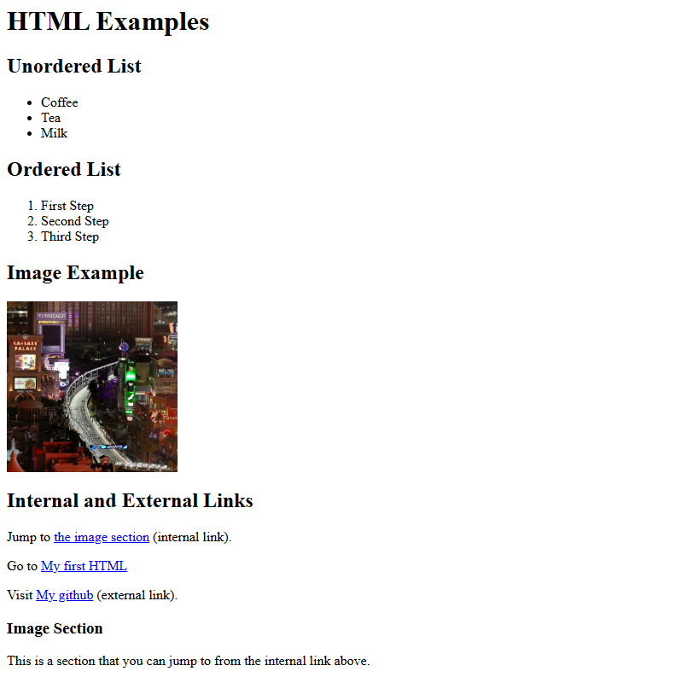

Q3. Create an HTML document for displaying the current semester’s timetable.
<html>
<head>
<title>My Semester 1 Timetable</title>
<style>
body { font-family: 'Times New Roman', Times, serif; background: #dfcdaf;}
table { width:100%; border-collapse:collapse; background: #ffffff; }
th, td { border:1px solid #444; padding:4px; text-align:center;}
tbody tr:nth-child(even) { background:#ffffff; }
.lunch { background:#ffe08a; font-weight:600; }
.empty { color:#717070; }
.dsc { font-size:13px; line-height:1.2; color: #0f0e0e; font-weight:bold; }
.aec { font-size:13px; line-height:1.2; color: chocolate;}
.vac { font-size:13px; line-height:1.2; color: blueviolet;}
.sec { font-size:13px; line-height:1.2; color: rgba(5, 151, 22, 0.609); font-weight: bold;}
.ge { font-size:13px; line-height:1.2; color: red;}
</style>
</head>
<body>
<h1>Semester 1 Timetable of Panshul Vikram Aggarwal</h1>

<table>
<thead>
<tr>
<b>
<th>Day / Time</th>
<th>08:30–09:30</th>
<th>09:30–10:30</th>
<th>10:30–11:30</th>
<th>11:30–12:30</th>
<th>12:30–01:00<br>Lunch</th>
<th>01:00–02:00</th>
<th>02:00–03:00</th>
<th>03:00–04:00</th>
<th>04:00–05:00</th>
<th>05:00–06:00</th>
</b>
</tr>
</thead>
<tbody>
<!-- Monday -->
<tr>
<td>Monday</td>
<td class="dsc">DSC CS OOP using Python (L)<br>Mr. Vipin Kumar Rathi<br>Sec 1, P30</td>
<td class="dsc">DSC CS OOP using Python (L)<br>Mr. Vipin Kumar Rathi<br>Sec 1, P30</td>
<td class="empty">—</td>
<td class="empty">—</td>
<td class="lunch">LUNCH</td>
<td class="dsc">DSC Math for Computing (L)<br>Dr. Aakash (OR)<br>Sec 1, P29</td>
<td class="dsc">DSC Math for Computing (L)<br>Dr. Aakash (OR)<br>Sec 1, P29</td>
<td class="empty">—</td>
<td class="empty">—</td>
<td class="empty">—</td>
</tr>

<!-- Tuesday -->
<tr>
<td>Tuesday</td>
<td class="dsc">DSC CSA Practical<br>Dr. Kamlesh K. Raghuvanshi<br>Sec 1, P30</td>
<td class="aec">AEC Hindi Aupachaarik Lekhan B (L)<br>Mr. Sudhanshu M. Kestwal<br>Sec 2, P3</td>
<td class="aec">AEC Hindi Aupachaarik Lekhan B (L)<br>Mr. Sudhanshu M. Kestwal<br>Sec 2, P3</td>
<td class="empty">—</td>
<td class="lunch">LUNCH</td>
<td class="dsc">DSC Math for Computing (L)<br>Dr. Aakash (OR)<br>Sec 1, P29</td>
<td class="vac">VAC Financial Literacy (P)<br>Mr. Ashish Yadav<br>Sec 3, P26</td>
<td class="vac">VAC Financial Literacy (P)<br>Mr. Ashish Yadav<br>Sec 3, P26</td>
<td class="sec">SEC Front End Web Design & Dev (P)<br>Sonia Sodhi<br>Sec 1, 203</td>
<td class="sec">SEC Front End Web Design & Dev (P)<br>Sonia Sodhi<br>Sec 1, 203</td>
</tr>

<!-- Wednesday -->
<tr>
<td>Wednesday</td>
<td class="dsc">DSC OOP Python (P)<br>Mr. Sahil Pathak, Mr. Vipin K. Rathi<br>Sec 1, Lab 3 PORTA</td>
<td class="dsc">DSC OOP Python (P)<br>Mr. Sahil Pathak, Mr. Vipin K. Rathi<br>Sec 1, Lab 3 PORTA</td>
<td class="empty">—</td>
<td class="empty">—</td>
<td class="lunch">LUNCH</td>
<td class="vac">VAC Financial Literacy (L)<br>Mr. Ashish Yadav<br>Sec 3, P26</td>
<td class="ge">GE ECO Essentials of Economics (L)<br>Ms. Vandana Rathore<br>Sec 1, P1</td>
<td class="ge">GE ECO Essentials of Economics (L)<br>Ms. Vandana Rathore<br>Sec 1, P1</td>
<td class="empty">—</td>
<td class="empty">—</td>
</tr>

<!-- Thursday -->
<tr>
<td>Thursday</td>
<td class="dsc">DSC OOP using Python (L)<br>Mr. Vipin Kumar Rathi<br>Sec 1, P29</td>
<td class="dsc">DSC CSA Practical (P)<br>Dr. Nikhil K. Rajput, Dr. Kamlesh K. Raghuvanshi<br>Sec 1, Lab 3 PORTA</td>
<td class="dsc">DSC CSA Practical (P)<br>Dr. Nikhil K. Rajput, Dr. Kamlesh K. Raghuvanshi<br>Sec 1, Lab 3 PORTA</td>
<td class="empty">—</td>
<td class="lunch">LUNCH</td>
<td class="ge">GE ECO Essentials of Economics (L)<br>Ms. Isha Gangwani<br>Sec 1, P1</td>
<td class="ge">GE ECO Essentials of Economics (T)<br>Ms. Isha Gangwani<br>Sec 1, P1</td>
<td class="empty">—</td>
<td class="empty">—</td>
<td class="empty">—</td>
</tr>

<!-- Friday -->
<tr>
<td>Friday</td>
<td class="dsc">DSC CSA Practical (L)<br>Dr. Kamlesh K. Raghuvanshi<br>Sec 1, P30</td>
<td class="dsc">DSC CSA Practical (L)<br>Dr. Kamlesh K. Raghuvanshi<br>Sec 1, P30</td>
<td class="dsc">DSC Math for Computing (P)<br>Dr. Aakash (OR)<br>Sec 1, Lab 3 PORTA</td>
<td class="dsc">DSC Math for Computing (P)<br>Dr. Aakash (OR)<br>Sec 1, Lab 3 PORTA</td>
<td class="lunch">LUNCH</td>
<td class="empty">—</td>
<td class="empty">—</td>
<td class="empty">—</td>
<td class="empty">—</td>
<td class="empty">—</td>
</tr>

<!-- Saturday -->
<tr>
<td>Saturday</td>
<td class="empty">—</td>
<td class="empty">—</td>
<td class="empty">—</td>
<td class="empty">—</td>
<td class="lunch">LUNCH</td>
<td class="empty">—</td>
<td class="empty">—</td>
<td class="empty">—</td>
<td class="empty">—</td>
<td class="empty">—</td>
</tr>

<!-- Sunday -->
<tr>
<td>Sunday</td>
<td class="empty">—</td>
<td class="empty">—</td>
<td class="empty">—</td>
<td class="empty">—</td>
<td class="lunch">LUNCH</td>
<td class="empty">—</td>
<td class="empty">—</td>
<td class="empty">—</td>
<td class="empty">—</td>
<td class="empty">—</td>
</tr>
</tbody>
</table>
</body>
</html>

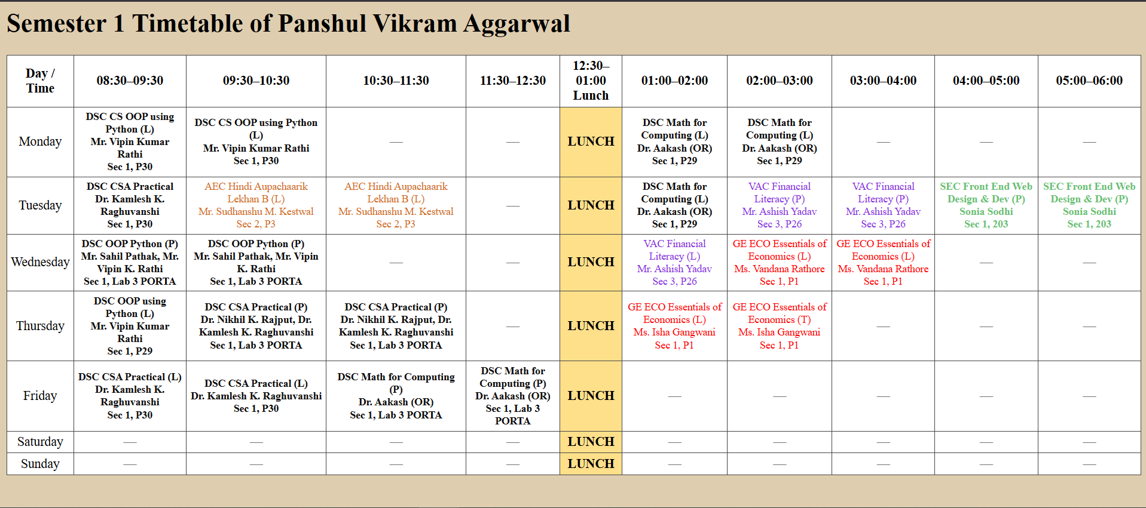Q4. Create a website with horizontal and vertical frames. Top horizontal frame needs to show your college’s name and logo. Bottom horizontal frame is to be split into two vertical frames. The left frame has hyperlinks to pages related to faculty, courses, student activities, etc. The right frame shows the corresponding webpage based on the link clicked on the left frame.

<!DOCTYPE html>
<html>
<head>
<title>Ramanujan College</title>
<meta name="viewport" content="width=device-width, initial-scale=1">
<style>
body { margin:0; font-family:Arial; }

/* Top header */
.header {
height: 90px;
background: #f65a29;
color: white;
display: flex;
align-items: center;
padding: 15px;
gap: 15px;
}

.header img {
height: 60px;
}

/* Layout: left + right */
.layout {
display: flex;
height: calc(100vh - 90px);
}

/* Left menu */
.menu {
width: 240px;
background: #e6f2ff;
padding: 15px;
overflow-y: auto;
}

.menu a {
display: block;
padding: 10px;
margin-bottom: 8px;
background: white;
border-radius: 6px;
text-decoration: none;
font-weight: bold;
color: #f65a29;
border: 1px solid #ddd;
}

.menu a:hover { background:#f65a29; color:white; }

/* Right content */
iframe {
width: 100%;
height: 100%;
border: none;
background: white;
}
</style>
</head>

<body>

<!-- TOP HEADER -->
<div class="header">
<img src="https://ramanujancollege.ac.in/media/images/Logo_RCDU_8oecNot.original.png">
<h2>Ramanujan College — Student / Faculty Portal</h2>
</div>

<!-- MAIN LAYOUT -->
<div class="layout">

<!-- LEFT MENU -->
<div class="menu">
<a href="#" onclick="loadPage('faculty')">Faculty</a>
<a href="#" onclick="loadPage('courses')">Courses</a>
<a href="#" onclick="loadPage('activities')">Student Activities</a>
<a href="#" onclick="loadPage('contact')">Contact</a>
</div>

<!-- RIGHT CONTENT -->
<iframe id="contentFrame"
srcdoc="<h2 style='padding:20px;'>Welcome to Ramanujan College Portal<br>Select a section from the left.</h2>">
</iframe>

</div>

<script>
/* ------------------ In-memory pages ------------------ */
const PAGES = {

faculty: `
<!DOCTYPE html><html><body style='font-family:Arial;padding:20px;'>
<h1>Faculty</h1>
<h2>Teachers</h2>
<ol style="line-height:1.6;">
<li>Dr. Aakash</li>
<li>Dr. Kamlesh Raghuvanshi</li>
<li>Mr. Vipin Rathi</li>
<li>Mr. Nikhil Kumar</li>
<li>Mr. Sahil Pathak</li>
<li>Ms. Vandana Rathore</li>
<li>Ms. Isha Gangwani</li>
<li>Mr. Ashish Yadav</li>
<li>Ms. Sonia Sodhi</li>
<li>Mr. Sudhanshu Kestwal</li>
</ol>

<h2>Staff</h2>
<ul>
<li>Mr. Sanjay Bhandari – Senior PA</li>
<li>Ms. Nidhi Mathur – Senior Assistant</li>
<li>Mr. Jitender Sharma – MTS</li>
</ul>

</body></html>
`,

courses: `
<!DOCTYPE html><html><body style='font-family:Arial;padding:20px;'>
<h2>Courses Offered</h2>
<h3>Honours</h3>
<ul>
<li>B.Sc. (Hons.) Computer Science</li>
<li>B.Sc. (H) Statistics</li>
<li>B.Sc. (H) Mathematics</li>
<li>B.Sc. (H) Environmental Sciences</li>
<li>B.A. (H) Economics</li>
<li>B.A. (H) English</li>
<li>B.A. (H) Hindi</li>
<li>B.A. (H) Philosophy</li>
<li>B.A. (H) Political Science</li>
<li>B.A. (H) Applied Psychology</li>
<li>B.Com (H)</li>
<li>B.Voc. Software Development</li>
</ul>
</body></html>
`,

activities: `
<!DOCTYPE html><html><body style='font-family:Arial;padding:20px;'>
<h2>Student Activities</h2>
<ul>
<li>TechSoc — Coding Competitions & Workshops</li>
<li>FinClub — Financial Literacy Sessions</li>
<li>Cultural Fest — Abhivyakti</li>
<li>Sports Meet — Annual Athletics & Games</li>
</ul>
</body></html>
`,

contact: `
<!DOCTYPE html><html><body style='font-family:Arial;padding:20px;'>
<h2>Contact</h2>
<p>Email: info@ramanujancollege.example</p>
<p>Office: Ramanujan College</p>
</body></html>
`
};

/* ------------------ Loader ------------------ */
function loadPage(name) {
document.getElementById("contentFrame").srcdoc = PAGES[name];
}
</script>

</body>
</html>
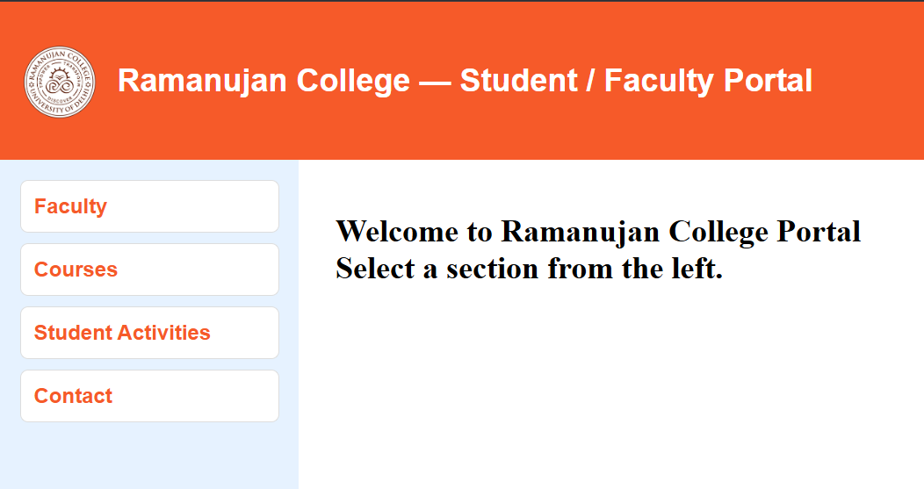
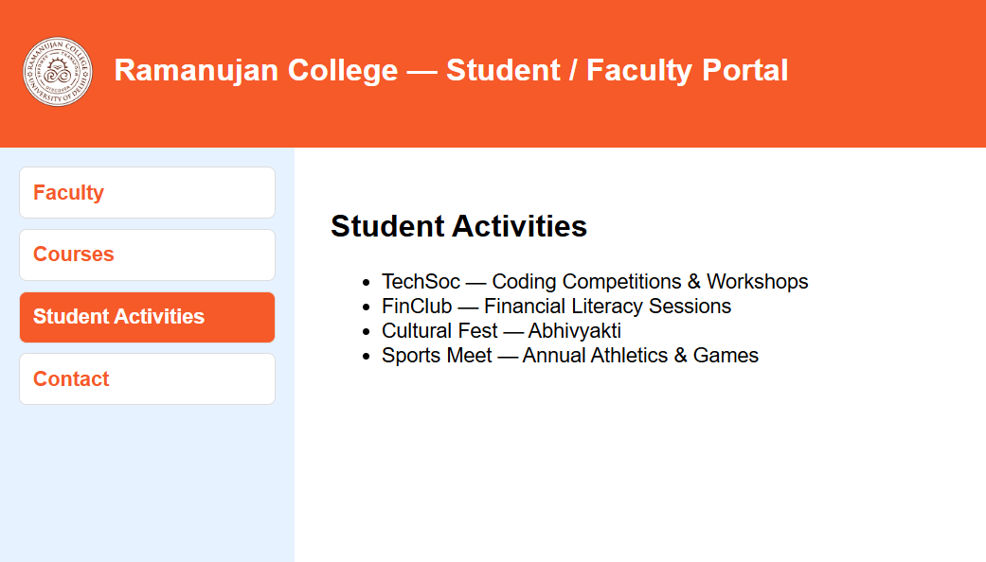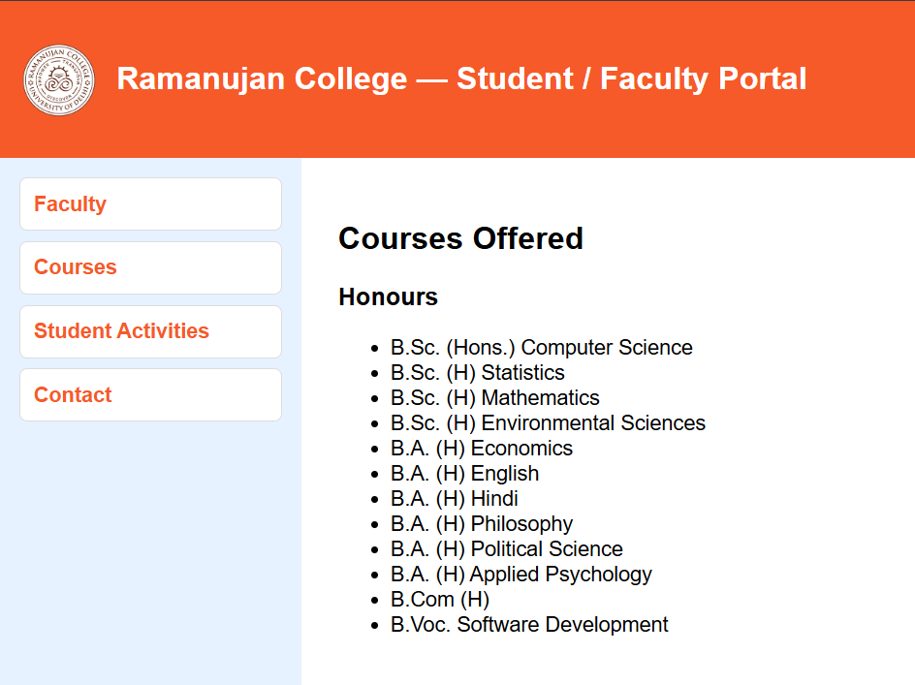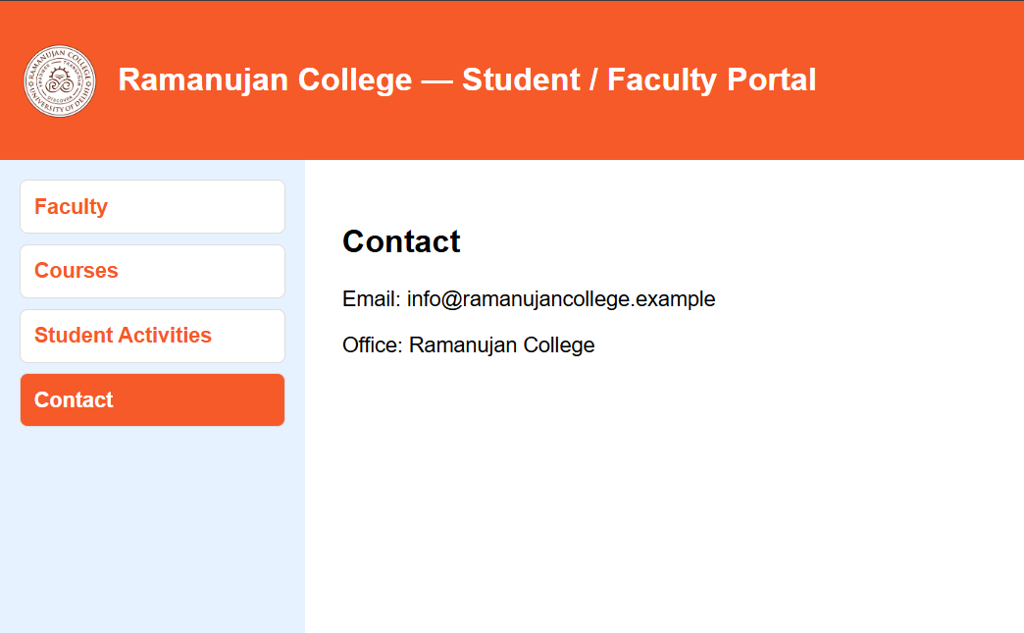

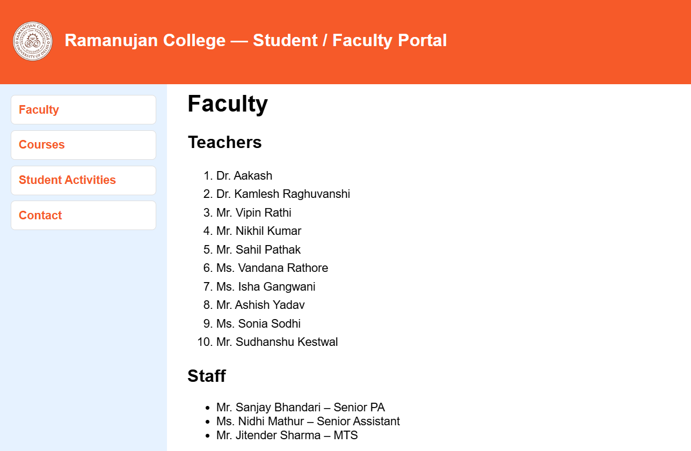

Q5. Create a student registration form using HTML which has the following controls and make an interactive content presentation using CSS.: I. Text Box II. Dropdown box III. Option/radio buttons IV. Check boxes V. Reset and Submit button

<!DOCTYPE html>
<html lang="en">
<head>
<meta charset="UTF-8">
<meta name="viewport" content="width=device-width, initial-scale=1.0">
<title>Student Registration Form</title>
<style>
body {
font-family: Arial, sans-serif;
background: #eef2f3;
padding: 20px;
}

.form-box {
width: 400px;
background: white;
padding: 20px;
border-radius: 8px;
box-shadow: 0 0 10px rgba(0, 0, 0, 0.2);
}

form {
display: flex;
flex-direction: column;
}

label {
font-weight: bold;
margin-top: 10px;
}

input, select {
width: 100%;
padding: 8px;
margin: 8px 0;
box-sizing: border-box;
}

.gender-group, .hobbies-group {
display: flex;
gap: 20px;
align-items: center;
flex-wrap: wrap;
}

.hobbies-group input {
margin: 5px 10px 5px 0;
}

.submit-group {
display: flex;
justify-content: space-between;
gap: 10px;
}

</style>
</head>
<body>

<h2>Student Registration Form</h2>
<div class="form-box">
<form>
<label for="name">Name:</label>
<input type="text" id="name" placeholder="Enter your name" />

<label for="department">Department:</label>
<select id="department">
<option>Bsc. Computer Science (Hons.)</option>
<option>Bvoc. Software Development</option>
<option>BMS</option>
<option>B.A. Program</option>
</select>

<label>Gender:</label>
<div class="gender-group">
<label><input type="radio" name="g" /> Male</label>
<label><input type="radio" name="g" /> Female</label>
<label><input type="radio" name="g" /> Other</label>
</div>

<label>Hobbies:</label>
<div class="hobbies-group">
<label><input type="checkbox" /> Developing</label>
<label><input type="checkbox" /> Making a canvas</label>
<label><input type="checkbox" /> Sports</label>
<label><input type="checkbox" /> Cinema</label>
<label><input type="checkbox" /> Making Music</label>
</div>

<div class="submit-group">
<input type="reset" value="Reset" />
<input type="submit" value="Submit" />
</div>
</form>
</div>

</body>
</html>

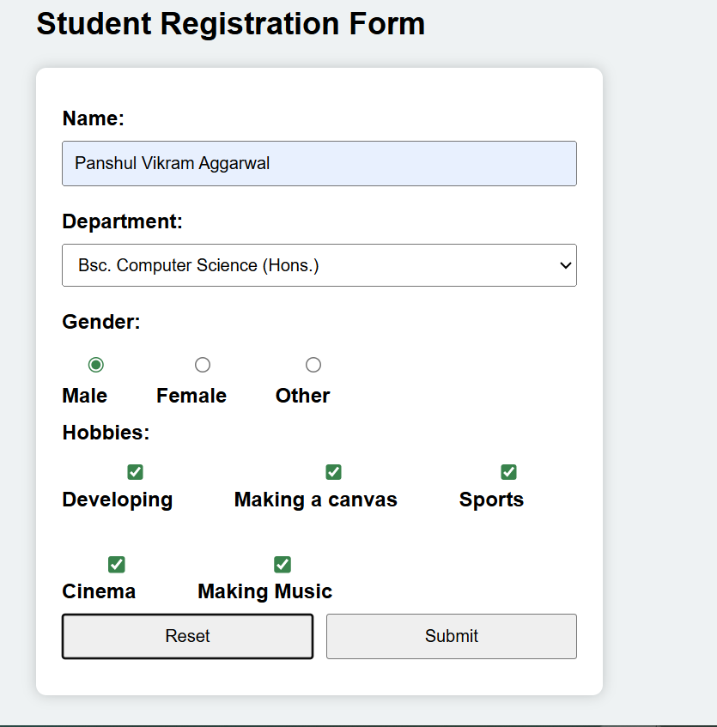

Q6. Create a webpage for your department with a drop-down navigation menu for faculty, courses, activities, etc.. Implement the webpage using styles, rules, selectors etc. learned in CSS

<html>
<head>
<title>Practicle 6</title>
<style>
:root{
--bg:#f2f4f7; --nav:#173a5e; --accent:#2a9df4; --card:#ffffff;
}
*{box-sizing:border-box}
body{font-family:Inter, Arial, sans-serif; margin:0; background:var(--bg); color:#111}

/* Top navigation */
.topbar{
background:var(--nav); color:#fff; padding:10px 16px; display:flex; align-items:center; justify-content:space-between;
}

/* Nav menu */
nav{display:flex; gap:8px; align-items:center}
.nav-link{color:#fff; text-decoration:none; padding:8px 12px; border-radius:6px; display:inline-block}
.nav-link:hover{background:rgba(255,255,255,0.06)}

/* Dropdown */
.dropdown{position:relative}
.dropbtn{background:none;border:none;color:inherit;padding:8px 12px;font:inherit;cursor:pointer;border-radius:6px}
.dropdown-menu{position:absolute; left:0; top:calc(100% + 8px); display:none; min-width:220px; background:var(--card); box-shadow:0 6px 20px rgba(20,30,40,0.12); border-radius:8px; overflow:hidden}
.dropdown-menu a{display:block;padding:10px 14px;color:#0d2540;text-decoration:none}
.dropdown-menu a:hover{background:var(--bg)}
.dropdown:focus-within .dropdown-menu,.dropdown:hover .dropdown-menu{display:block}

/* Page content */
.container{max-width:1100px;margin:28px auto;padding:0 16px}
.hero{background:linear-gradient(90deg,rgba(42,157,244,0.08),transparent); padding:22px;border-radius:10px}
.cards{display:grid;grid-template-columns:repeat(auto-fit,minmax(240px,1fr));gap:14px;margin-top:16px}
.card{background:var(--card);padding:16px;border-radius:10px;box-shadow:0 6px 18px rgba(20,30,40,0.06)}

footer{text-align:center;padding:18px;color:#666}
</style>
</head>
<body>

<header class="topbar">
<div class="brand">Computer Science Department</div>
<nav id="mainNav">
<a class="nav-link" href="#">Home</a>

<div class="dropdown" tabindex="0">
<button class="dropbtn">Department ▾</button>
<div class="dropdown-menu" role="menu">
<a href="#faculty">Faculty</a>
<a href="#courses">Courses</a>
<a href="#activities">Activities</a>
<a href="#research">Research</a>
</div>
</div>

<a class="nav-link" href="#contact">Contact</a>
</nav>
</header>

<main class="container">
<section class="hero">
<h2>Welcome to the Computer Science Department</h2>
<p style="margin:8px 0 0">This page demonstrates a styled navigation with accessible dropdowns, responsive behavior and example content sections using CSS selectors and rules.</p>
</section>

<section class="cards">
<article id="overview" class="card">
<h3>B.Sc. (Hons) Computer Science – Overview</h3>
<p>The B.Sc. (Hons) Computer Science programme provides a strong foundation in computational theory, algorithms, programming, operating systems, networks, software engineering, and emerging technologies.</p>
<p>Designed per University of Delhi guidelines, the course combines theory, labs, minor/major projects, internships, and skill enhancement papers.</p>
</article>

<article id="eligibility" class="card">
<h3>Eligibility & Admission</h3>
<ul>
<li>Admission through CUET (UG) as per University of Delhi rules.</li>
<li>10+2 with Mathematics as a compulsory subject.</li>
<li>Merit-based seat allocation via CSAS portal.</li>
</ul>
</article>

<article id="courses" class="card">
<h3>Core Courses</h3>
<ul>
<li>Programming in C++ / Java</li>
<li>Data Structures</li>
<li>Computer System Architecture</li>
<li>Operating Systems</li>
<li>Database Management Systems</li>
<li>Computer Networks</li>
<li>Software Engineering</li>
<li>Theory of Computation</li>
<li>Artificial Intelligence</li>
<li>Internet Technologies</li>
</ul>
</article>

<article id="ge" class="card">
<h3>General Electives (GE)</h3>
<p>Students may choose GE subjects offered across all departments of the college, including:</p>
<ul>
<li>Mathematical Sciences</li>
<li>Electronics</li>
<li>Commerce</li>
<li>Psychology</li>
</ul>
</article>

<article id="sec" class="card">
<h3>Skill Enhancement Courses (SEC)</h3>
<ul>
<li>Python Programming</li>
<li>Android Development</li>
<li>Cyber Security Tools</li>
<li>Web Design & Hosting</li>
</ul>
</article>

<article id="faculty" class="card">
<h3>Faculty (B.Sc. CS Hons)</h3>
<ul>
</ul>
<li>Dr. Aakash (OR)</li>
<li>Mr. Vipin Rathi</li>
<li>Dr. Kamlesh Raghuvanshi</li>
</article>

<article id="labs" class="card">
<h3>Laboratories</h3>
<ul>
<li>Fully equipped Computer Labs with 16gb ram i7 and 4gb video cards</li>
<li>High-performance networking infrastructure</li>
<li>Linux, Windows, Docker, and Cloud lab environments</li>
</ul>
</article>

<article id="activities" class="card">
<h3>Department Activities</h3>
<ul>
<li>Seminars & Expert Talks</li>
<li>Hackathons & Coding Contests</li>
<li>Workshops on AI, Web Dev, Cybersecurity</li>
<li>Annual Tech Fest – CODEX</li>
<li>Research & Innovation Projects</li>
</ul>
</article>

<article id="careers" class="card">
<h3>Career Opportunities</h3>
<ul>
<li>Software Developer</li>
<li>Data Analyst / ML Engineer</li>
<li>Cybersecurity Analyst</li>
<li>Full-Stack Web Developer</li>
<li>Cloud Engineer</li>
<li>System Administrator</li>
<li>Higher Studies (MCA, M.Sc CS, M.Tech, MBA,Ph.D, etc.)</li>
</ul>
</article>
</section>
</main>

<footer>
© Ramanujan College — Computer Science Department
</footer>

</body>
</html>

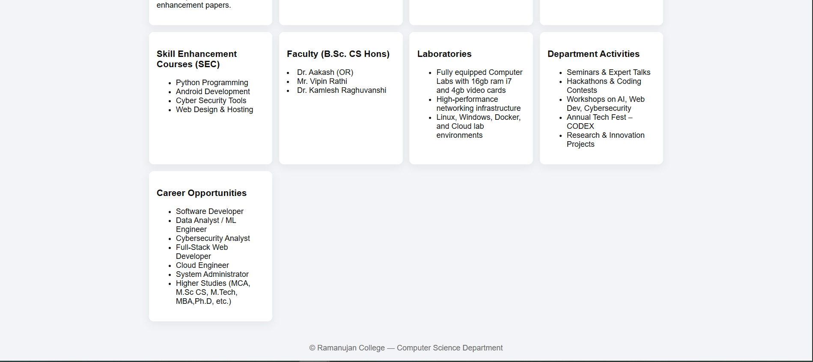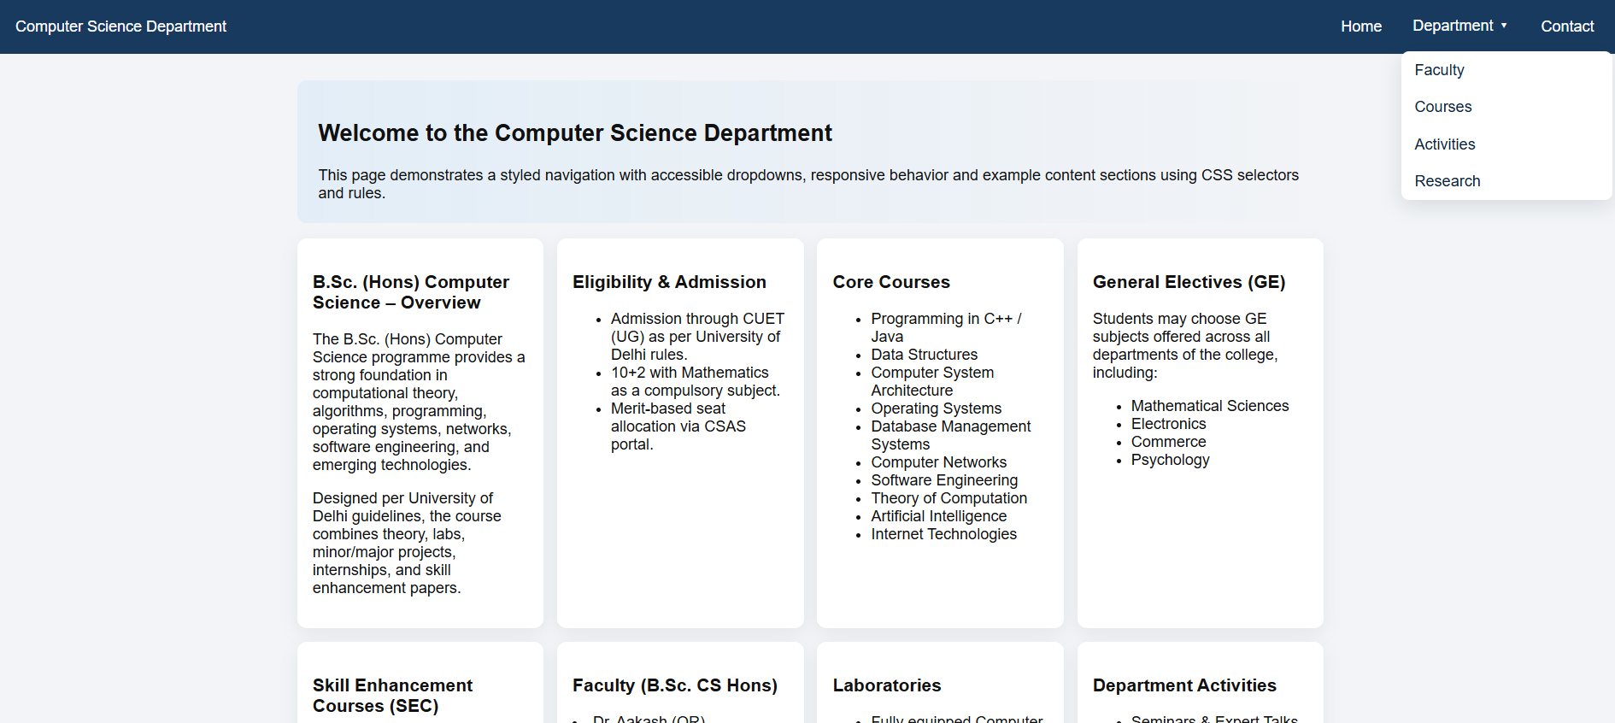

Q7. Write event-driven programs in JavaScript for the following: ○ Enter a number and on click of a button print its multiplication table. ○ Print the largest of three numbers entered by the user. ○ Find the factorial of a number entered by the user. ○ Enter a list of positive numbers using the prompt terminated by a zero. Find thesum and average of these numbers.

<!DOCTYPE html>
<html lang="en">
<head>
<meta charset="UTF-8">
<title>Practicle 7</title>
<style>
body { font-family: Arial; background: #f7f7f7; padding: 20px; }
.section {
background: white;
padding: 20px;
margin-bottom: 20px;
border-radius: 8px;
box-shadow: 0 0 8px rgba(0,0,0,0.1);
width: 400px;
}
input { width: 100%; padding: 8px; margin: 8px 0; }
button { padding: 8px 14px; margin-top: 5px; cursor: pointer; }
pre { background: #eee; padding: 10px; border-radius: 5px; }
</style>
</head>
<body>
<h2>JavaScript Event-Driven Programs</h2>

<!-- Multiplication Table -->
<div class="section">
<h3>Multiplication Table</h3>
<input id="num" type="number" placeholder="Enter a number" />
<button onclick="table()">Print Table</button>
<pre id="out1"></pre>
</div>

<!-- Largest of Three Numbers -->
<div class="section">
<h3>Largest of Three Numbers</h3>
<input id="a" type="number" placeholder="First number">
<input id="b" type="number" placeholder="Second number">
<input id="c" type="number" placeholder="Third number">
<button onclick="largest()">Find Largest</button>
<p id="out2"></p>
</div>

<!-- Factorial -->
<div class="section">
<h3>Factorial</h3>
<input id="f" type="number" placeholder="Enter a number">
<button onclick="fact()">Find Factorial</button>
<p id="out3"></p>
</div>

<!-- Sum & Average -->
<div class="section">
<h3>Sum & Average (Stop with 0)</h3>
<button onclick="sumavg()">Start Input</button>
<p id="out4"></p>
</div>

<script>
function table() {
let n = document.getElementById('num').value;
let o = "";
for (let i = 1; i <= 10; i++) o += `${n} x ${i} = ${n*i}\n`;
document.getElementById('out1').textContent = o;
}

function largest() {
let x = +document.getElementById('a').value,
y = +document.getElementById('b').value,
z = +document.getElementById('c').value;
document.getElementById('out2').textContent = "Largest = " + Math.max(x, y, z);
}

function fact() {
let n = +document.getElementById('f').value;
let r = 1;
for (let i = 1; i <= n; i++) r *= i;
document.getElementById('out3').textContent = "Factorial = " + r;
}

function sumavg() {
let sum = 0, count = 0, num;
while (true) {
num = Number(prompt('Enter number (0 to stop):'));
if (num === 0) break;
if (num > 0) {
sum += num;
count++;
}
}
document.getElementById('out4').textContent = `Sum = ${sum}, Average = ${sum / count}`;
}
</script>

</body>
</html>

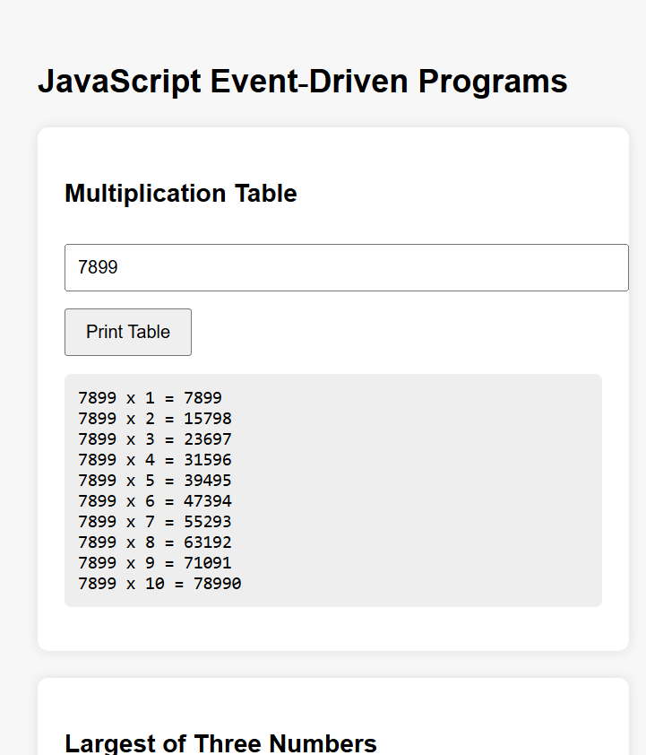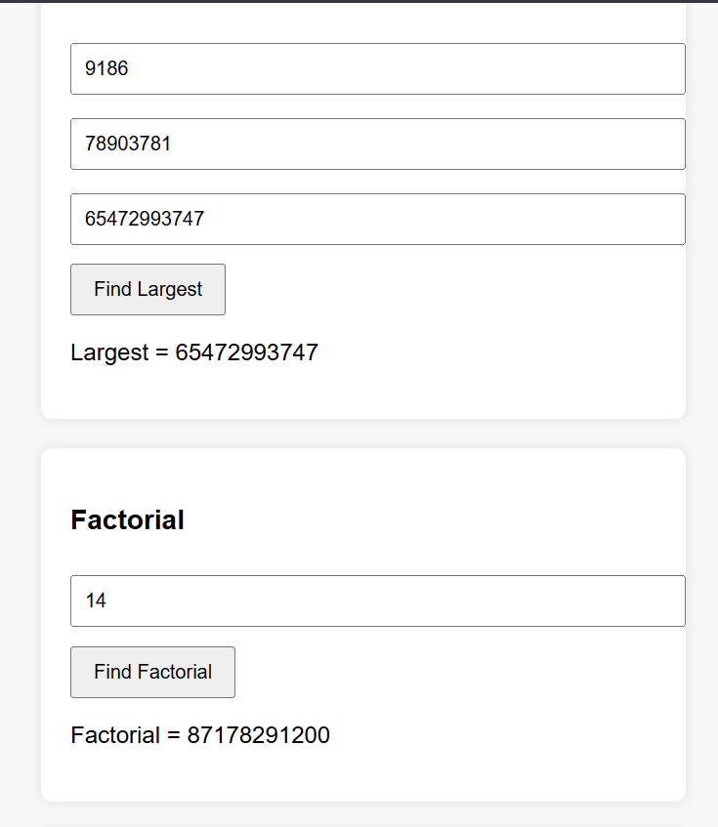

Q8. Create a student registration form using text, radio button, check box, drop down box, text field and all other required HTML elements. Customize the CSS and javascript to input and validate all data. Create functions to perform validation of each element, example: ○ Roll number is a 7-digit numeric value ○ Name should be an alphabetical value (String) ○ Non-empty and valid fields like DOB

<html>
<head>
<meta name="viewport" content="width=device-width, initial-scale=1.0">
<title>Student Information Form</title>
</head>
<body>

<h2 style="text-align:center;">Student Information Form</h2>
<form>

<label>Full Name:</label><br>
<input type="text" placeholder="Enter your full name"><br><br>

<label>Roll Number:</label><br>
<input type="text" placeholder="Enter roll number"><br><br>

<label>Email:</label><br>
<input type="email" placeholder="Enter email"><br><br>

<label>Phone Number:</label><br>
<input type="tel" placeholder="Enter phone number"><br><br>

<label>Gender:</label><br>
<input type="radio" name="gender"> Male
<input type="radio" name="gender"> Female
<input type="radio" name="gender"> Other<br><br>

<label>Course:</label><br>
<select>
<option>B.Sc (Hons) Computer Science</option>
<option>B.Voc. Software Development</option>
<option>B.A Programme</option>
<option>BMS</option>
</select><br><br>

<label>Year:</label><br>
<select>
<option>1st Year</option>
<option>2nd Year</option>
<option>3rd Year</option>
</select><br><br>

<label>Skills:</label><br>
<input type="checkbox"> C Programming<br>
<input type="checkbox"> Python<br>
<input type="checkbox"> Java<br>
<input type="checkbox"> Web Development<br><br>

<label>Upload Photo:</label><br>
<input type="file"><br><br>

<label>Address:</label><br>
<textarea rows="4" cols="40" placeholder="Enter address"></textarea><br><br>

<button type="submit">Submit</button>

</form>

</body>
</html>

